DEPARTMENT OF MECHANICAL ENGINEERING
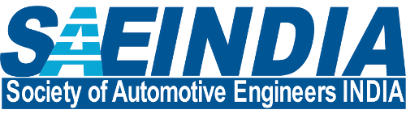
SOCIETY OF AUTOMOTIVE ENGINEERS INDIA
SAE Activities 2017-18

Sr. No. | Title of Activity / Workshop | Resource Person – Name, Designation & Organization | Date Conducted | Target Audience
1. | Design presentation in qualifying round of National event BAJA 2018. | SAE core technical team | 14/07/2017 and 15/06/2017 | Event judged by Technical Experts
2. | Participation in National event BAJA 2018 at Indore. | Entire SAE technical team | 25/01/2018 to 27/01/2018 | Event live on You Tube
3. | Design War on Solid Works model | SAE team members | 15/10/2017 | Students from SIESGT
 | Quiz on Automobile | SAE technical team | 15/10/2017 | Students from SIESGT

~ * ~ * ~

